Splunk Data Delay
Troubleshooting & Resolution Guide
Covers: what delay is, why it happens, how to troubleshoot from Search (SPL), and how to resolve it — including the common TcpOutputProc blocked_seconds scenario.

Part 1: Why Delay Happens (Reasons)
Splunk data flows through a pipeline with queues between each stage:
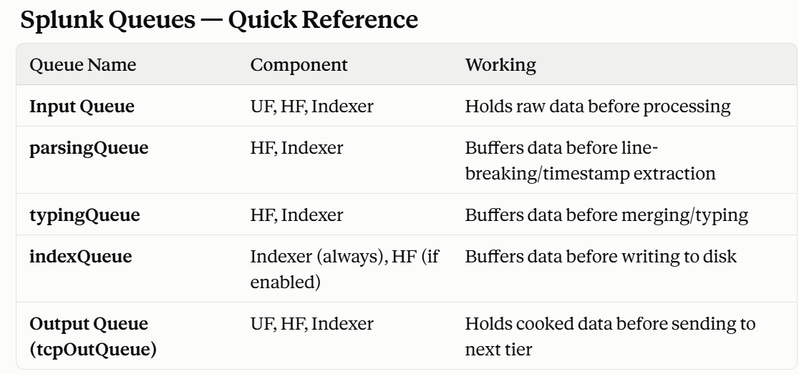
Delay happens when any queue gets full and creates backpressure. Common reasons:
# | Reason | Where It Occurs
1 | Receiver (indexer) not accepting data | Causes tcpOutQueue to fill on forwarder
2 | Disk full on indexer (minFreeSpace hit) | Indexer stops indexing
4 | Indexer overloaded (CPU / disk I/O) | indexQueue fills up
5 | Network / firewall issue | Forwarder can't reach receiver

Part 3: How to Troubleshoot (Step-by-Step, from Search)

TcpInputProc is the component on the receiver/indexer responsible for accepting incoming data from forwarders (UF/HF). Warnings/errors here mean the receiver is having trouble accepting connections or incoming data

Step 1 — Check for TCP Output Blocking (Forwarder side)

Search – index=_internal host=redhat2 “WARN”

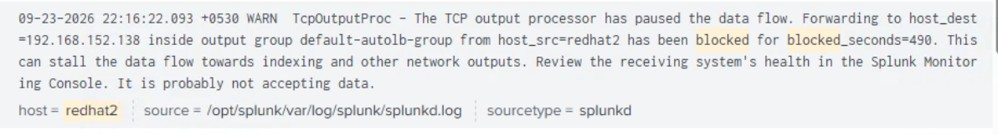
- host_dest = the receiver you need to investigate next
- Increasing blocked_seconds = ongoing problem

Step 3 — Check Which Queue Is Full (Forwarder side)e

Search - index=_internal host=redhat2 group=queue

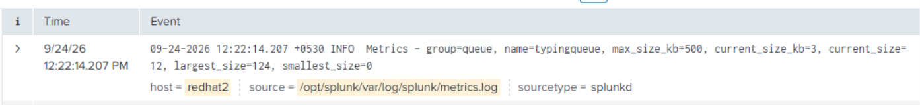

If current_size_kb is close to max_size_kb → that queue is full/bottlenecked.

Step 4 — Check Throughput Drop

Search - index=_internal host=redhat2 group=thruput

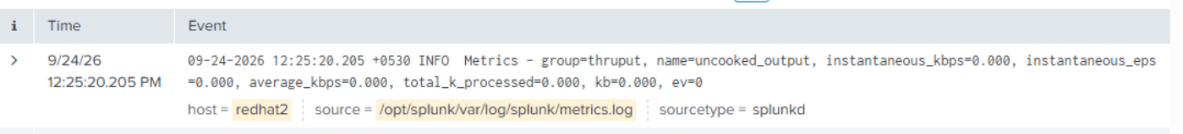
- Near-zero values while data should flow = ingestion stalled

Step 5 — Investigate the Receiver (Indexer)
Using the host_dest IP from Step 2:

Search - index=_internal host=redhat3 component=TcpInputProc log_level=WARN OR log_level=ERROR

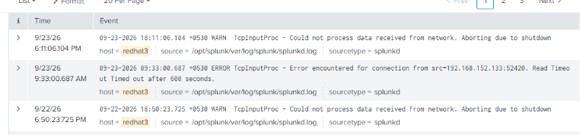

Part 4: How to Resolve (Fix by Root Cause)

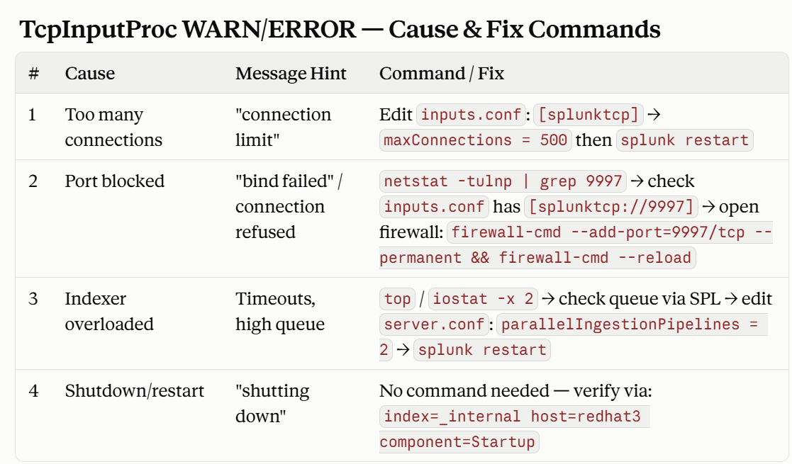

Part 5: Verify the Fix Worked
Check blocking stopped:
Search – index=_internal host=redhat2 “Connected to”
